Predictors of the macroinvertebrate fauna in semiarid aquatic systems
  - Assemblage structure of freshwater macroinvertebrates in semiarid Brazil: importance of habitat structure Habitat structure is more importand than sediment type as predictor of the macroinvertebrate fauna in semiarid aquatic systems
Prof. Elvio S. F. Medeiros (Autor)
Rafaela L. de Farias (Autor)
Laryssa K. de Carvalho (Doutoranda)
Laboratório de Ecologia, Universidade Estadual da Paraíba, Campus V, João Pessoa, PB
Affiliation:
2026-03-10
Abstract
The benthic fauna in freshwaters is particularly subject to the effects of varying water flow due to their close association with the bottom substrate and its physical and chemical characteristics. It is then expected that the composition of benthic macroinvertebrate communities will show spatial and temporal patterns according to variations in site environmental characteristics. To test this hypothesis in semiarid aquatic systems, this study compares the benthic macroinvertebrate composition between natural aquatic ecosystems (intermittent rivers) and artificial ecosystems (reservoirs) in the Brazilian semiarid. Benthic invertebrates were sampled during the wet and dry seasons with a D type net (40cm wide and 250 nanometer grid) in two distinct areas in Brazilian semi-arid. A total amount of 28110 macroinvertebrate individuals has been collected, distributed into 35 taxonomic groups, out of which Thiaridae, Chironomidae larvae and Oligochaeta were the most representative. Richness and density were significantly different in the studied areas. Macroinvertebrate composition has presented spatial segregation between Seridó and Buíque regions as well as between artificial and natural localities. CCA has shown that benthic macroinvertebrate composition and environmental variables are related, with dissolved oxygen, flow, macrophytes, mud and sand being important fauna predicting factors.
Table of contents

1. Introduction
Aquatic macroinvertebrate communities are a widely studied ecological group known for their potential as biological indicators. Several studies have been developed in dryland aquatic systems worldwide and in semiarid Brazil. Their value as indicators have been recognized by CITAS, and they have been linked to a variety of environmental variables.

1.0.1 Objetctives
This study focused on the comparison of composition of benthic macroinvertebrates within natural aquatic systems (intermittent rivers) and artificial ones (reservoirs) in the Brazilian semi-arid, rather than across. It is not intended with this study to compare environments of regions since it is already expected for them to be different in terms of community composition and habitat structure (see for instance, R. L. Farias et al. (2012), R. L. D. Farias et al. (2020) and Carvalho et al. (2013)). We aim at understanding the temporal differences across these sites. The hypothesis to be tested is that, when analyzed separately, different environments will have specific variables associated with the composition of benthic macroinvertebrates assemblages, and these variables do not reflect the overall set of sites, but each one individually. And that environmental variables are important explicative elements has been tested, confirming the established knowledge that semiarid environments in Brazil are highly spatially segregated with different sets of environmental variables determining the benthic fauna. Before testing this hypothesis, we intend to show that all sites will have different community compositions and different habitat structure.
(RN2627?), (RN1965?), (RN361?)

2. Material and Methods

2.1 Study Area and Sampling Design
The present study was performed at the easter limits of the semiarid region of Brazil (Figure 1). This area is characterized by low average precipitation, concentrated in a few months of the year, usually between January and July (Figure 2), and high average annual temperatures between 20 and 32 °C (RN2966?). The main hydrological feature in the study area is the intermittence of surface water flow of its streams and rivers and, as a consequence, many man-made reservoirs built from the damming of the intermittent streams (RN2442?). These rivers flow through the “Caatinga”, a deciduous arboreal to shrubby open forest (RN1788?). The climate in the study area is semiarid (BS´h hot and dry) and equatorial (As, dry summer) (RN2614?). A diverse array of sampling sites was chosen to represent the most common aquatic environment types of semiarid Brazil, with different sets of specificities and across different catchment basins. We sampled six sites, three of which consisted of stream reaches with surface water flow (during the rainy season) or isolated temporary pools (during the dry season) (sites EP, CI, SE) and three sites in artificial reservoirs created from stream impoundment (sites MU, SA, RE). Sampling was conducted during the year of 2006 on four occasions during the rainy (April and June) and dry seasons (September and December) (Figure 1). Detailed information on the study sites and their, zooplankton and fish, fauna has been published elsewhere by (RN2491?), (RN2692?) and (RN1965?).

2.2 Data Collection
Environmental characteristics of each site were measured in four sets of variables: (a) site morphology, (b) water quality, (c) sediment composition, and (d) marginal habitat structure. Site morphology was assessed by their width (cm) and depth (cm) measured from three random transects. Catchment scale variables (such as elevation and river length) were measured using handheld GPS and satellite imagery. Water quality was evaluated as physical and chemical variables that were measured using portable equipment for temperature (°C) and dissolved oxygen (mg/L). Transparency (cm) was measured using a Secchi disk and water velocity (m/s) was estimated using the float method (RN1940?). Sediment composition and the habitat physical structure followed protocols from (RN2467?) and (RN2461?), adapted by (RN2491?), where they are estimated from 9 to 12 one meter quadrants along the margins (terrestrial-aquatic interface) and determined by visual estimation of sediment type percentage cover (mud, sand, cobbles, small gravel, large gravel, rocks and bedrock) and of littoral and sub-aquatic structures (macrophytes, littoral grass, leaf litter, attached algae, filamentous algae, overhanging vegetation, submerged vegetation, small woody debris, large woody debris and root masses). At each study site, three samples of benthic macroinvertebrates were collected in the margins using a D type net (40 cm wide and 250 μm) to represent different habitat types. Samples were fixed in situ with 4% formalin and subsequently preserved in 70% ethanol. Macroinvertebrate specimens were sorted and identified to the lowest possible taxonomic level, usually family ((RN372?), (RN782?), (RN188?) and (RN2990?), among others).

2.3 Statistical Analyses
Prior to statistical analysis, environmental variables were checked for multivariate collinearity and square root transformed to enhance normality and homogeneity of variances (RN67?).
These variables were subsequently subjected to Principal Component Analysis (PCA) to evaluate multivariate correlations among sites. Prior to analysis, site morphology and water quality variables were square root transformed, whereas sediment composition and the marginal habitat structure (which were measured as percentages) were arcsine square-root transformed after relativization by column total (RN1552?). PCA was performed using the FactoMineR package in R (RN1482?). All variables were centered and scaled to unit of variance.
For the macroinvertebrate community, all analyses were performed on density of individuals (ind/m²) calculated by the ratio between the number of individuals and the sampled area of the D-net in each sample. Macroinvertebrate fauna was described by means of average density and rarefied taxa richness, where richness was standardized by the average sample size across all samples. Life stages (larvae, pupae, nymph and adults) were treated as separate taxa, considering their ecological differences (RN636?). Comparisons of density and richness among study sites were tested by one-way ANOVA followed by post hoc multiple comparisons using Tukey’s HSD test (α=0.05) (RN158?).
A Stepwise Multiple Regression (SMR) analysis using the Akaike Information (MASS R package, stepAIC function, (RN2991?)) as the selection criterion was performed in both directions (forward and backward) to identify the best predictors across subsets of variables (site morphology, water quality, sediment composition and marginal habitat structures) for species richness and density (RN2907?).
Variation in species composition among sites were ordinated using Non-metric Multidimensional Scaling (NMDS) (RN361?). Data were arcsine square-root transformed after relativization and the Bray-Curtis distance was calculated. Significance of groups was tested using the Multi-Response Permutation Procedure (MRPP) ((RN2249?), (RN1552?)). For all MRPP analyses, the A value is presented as a measure of homogeneity degree in a cluster, as compared to random expectation.
Indicator Species Analysis (ISA) was performed to evaluate species–site associations (indicspecies R package, (RN3028?)) using the Indicator, or index, Value (IndVal) (RN3027?). The Indicator Value was calculated according to the method proposed by (RN2094?). This value was then tested for statistical significance by means of permutations (999 repetitions). Further explorations of species ecological preferences was performed using Multilevel Pattern Analysis with the multipatt fuction (RN3027?), based on correlation indices and the Pearson’s phi coefficient of association ((RN3026?), (RN3028?)). This coefficient is a measure of the correlation between two binary vectors. Phi was based on the presence–absence community matrix (RN3027?) and corrected for unequal group sizes (RN3029?).
To summarize the contribution of site environmental variables to species composition we performed distance-based Redundancy Analysis (dbRDA; (RN2969?)), implemented by the vegan R package (RN2832?), between each group of environmental variables (explanatory predictors) (site morphology, water quality, sediment composition and marginal habitat structure) and the community composition density matrix (response matrix) to see which environmental/habitat variables were the most important for determining each benthic community composition (RN361?). Multicollinearity across explanatory (environmental) variables was assessed using the Variance Inflation Factor (VIF) function (vif.cca). Highly collinear variables (VIF > 10) were excluded from the final model. Model significance was evaluated using permutation-based Analysis of Variance (ANOVA) (999 permutations) (RN2832?). To identify a parsimonious model, forward and backward stepwise model selection based on permutation tests was applied, retaining only predictors that significantly explained additional variation in community structure. The final RDA model was re-fitted using the selected variables and re-evaluated for collinearity and significance. Both sequential (Type I) and marginal (Type III) permutation tests were conducted, with marginal effects used to infer the independent contribution of each predictor.
RDA was applied to the density community matrix after being transformed by the Hellinger transformation (RN2904?). Only taxa with the highest absolute scores on the first canonical axis were labeled in the final ordination diagram. Environmental variables were transformed as previously stated for PCA. All statistical analyses were performed in the statistical environment of R v.2.9.0 (RN2774?).

3. Results

3.1 Environmental variables
Water flow was present only in smaller streams in lower altitudes (sites 4-6) and during the rainy season (0.10-0.17 m/s). Stream sites tended to be narrower with widths ranging from 5.4 to 29.6 m, compared with 72.2 to 330 m for reservoirs. Littoral depths varied widely from 4.7 to 81.3 cm across all sites. Dissolved oxygen (DO) ranged from 1.8 to 9.4 mg/L and temperatures from 24.0 and 35.2 °C. Turbidity was low with Secchi depths reaching 90 cm, even though some sites had depths as low as 16 cm of the Secchi disk. Mud and sand were the main substrates across all sampled sites (with average covers of 54.4 and 37.9%, respectively). The habitat elements that gave greater overall contributions were attached and filamentous algae (12% on average), littoral grass (9.0%) and aquatic macrophytes (8.4%), but these contributions varied widely across sites and season (Figure 10).
Principal Component Analysis described the overall structure of the study sites and the most important features in separating them in terms of their physical and chemical variables, site morphometry, sediment composition, and marginal habitat structure (Figure 2). PCA explained 41.9% of the variance in the environmental variables, with the first axis (27.6%) showing a gradient from large reservoirs to smaller streams sites. Large scale morphology variables such as altitude, river length and site width were important to describe most reservoirs, whereas river sites were better described by local physical, chemical and habitat variables, such as margins depth and water temperature. Among the habitat structure variations, overhanging vegetation and roots, were also important to describe stream sites. Larger reservoirs were mostly associated with a muddy substrate whereas river sites included a more diverse array of substrates, the most important being sand and gravel. Other variables such as slope (morphology), submerged vegetation and leaf litter (habitat structure) and water velocity (water quality) were important in explaining specific sites at given sampling occasions.

3.2 Benthic macroinvertebrates
A total amount of 28155 individuals was collected, divided into 32 taxonomic groups. Out of these, Thiaridae (1340.15 ind./m² ± 3068.95), larvae of Chironomidae (629.07 ind./m² ± 1424.72), and Oligochaeta (380.49 ind./m² ± 856.62) were the most the representative (Figure 11).
Sampling sites were different in macroinvertebrate rarefied richness (ANOVA d.f.= 5, 16; F_{richness} = 6.9; p=0.001) but not in density of individuals (ANOVA d.f.= 5, 16; F_{density} = 2.06; p = 0.124). According to post hoc Turkey tests, Cipó stream and the Recando reservoir had significantly higher rarefied richness when compared to the other study sites (p < 0.05) (Figure 3).
The Stepwise Multiple Regression Model (SMRM) was applied separately for each of the four sets of environmental variables (morphology, water quality, sediment composition and marginal habitat structures). Site morphology variables retained only stream width, with the final model explaining 15.4% of the variation (Adjusted R² = 0.111; d.f. = 1,20; F = 3.63, p = 0.071). Site width β = -0.36 (± 0.19), indicates that wider sites tend to have fewer species, although this effect was marginally significant (p = 0.071). River length had a strong negative effect on species richness (β = -1.96 ± 0.34), explaining 63.1% of its variation (Adjusted R² = 0.612; d.f. = 1, 20; F = 34.15, p < 0.001). The SMRM that best explained the water quality variables (42.3% of the variation in rarefied species richness) included water velocity and water temperature as significant predictors (Adjusted R² = 0.288; d.f. = 4,17; F = 3.12, p = 0.043). Water velocity (β = -19.97 ± 9.04) had a significant negative effect on species richness (p = 0.041) and water temperature (β = 16.11 ± 4.97) had a significant positive effect (p = 0.005). Dissolved oxygen and turbidity were not significant predictors (p > 0.05). Among the substrate composition variables, gravel was the only significant predictor, explaining 32.8% of the variation in rarefied species richness (Adjusted R² = 0.294; d.f. = 1,20; F = 9.76, p = 0.005, β = 1.85 ± 0.59). The SMRM for the habitat variables explained 58.6% of the variation in rarefied species richness (Adjusted R² = 0.379; d.f. = 7,14; F = 2.83, p = 0.046), with leaf litter (β = 6.24 ± 2.33, p = 0.018) and algal cover (β = 0.92 ± 0.41, p = 0.039) having significant positive effects on species richness. Other predictors such as roots (β = 4.71, p = 0.058) and littoral grass (β = -1.01, p = 0.052) may have been important showing marginal effects. Stepwise Multiple Regression was not performed between the environmental variables and species densities because the latter did not vary significantly across sites and sampling occasions.
Ordination analysis revealed a wide variation in community composition across sampling occasions with some degree of similarity within sites. The NMDS resulted in a non-metric fit (R²) of 0.97, with a stress of 0.173 (Figure 4).
Spatial segregation in macroinvertebrate composition was confirmed by MRPP, which shows significant differences between sites (A = 0.14, p = 0.001), but not for sampling months (A=-0.01, p=0.815) or seasons (wet/dry) (A < 0.01, p = 0.413). Differences between reservoir and stream sites were also significant (A = 0.03, p = 0.004).
Indicator Species Analysis identified ten taxa with significant indicator values (p < 0.05), partially overlapping with the multilevel pattern results. Several taxa were confirmed as indicators of RE, these being Oligochaeta, Conchostraca, Physidae and Coenagrionidae, all showing high indicator values (IndVal = 0.82-0.98, p < 0.03). Corixidae remained the solely indicator of CI (IndVal = 0.86, p = 0.013). Further exploration using Multilevel Pattern Analysis incorporated additional as indicators of specific site combinations, which were Ceratopogonidae and Libellulidae, for CI and RE (IndVal = 0.87-0.94, p < 0.007), Thiaridae and Atyidae, both associated with EP and SE (IndVal = 0.76-0.99, p < 0.048) and Planorbidae, associated with CI, RE, and SE (IndVal = 0.91, p = 0.048) (Figure 9).
Redundancy analysis (Figure 5) revealed a significant relationship between macroinvertebrate community composition and the site morphology variables, river length, maximum site depth, and site width (Permutation test, F_{3,18} = 4.71, p = 0.001). The constrained model explained 43.99% of the total community variation (adjusted R² = 0.35), with the remaining 56.01% attributable to unconstrained variation. The first RDA axis was highly significant (F_{1,18} = 11.33, p = 0.001) and accounted for 80.2% of the constrained inertia, whereas the second and third axes were not significant (p > 0.20). Sequential permutation tests indicated that channel width (F = 8.59, p = 0.001) and river length (F = 3.70, p = 0.013) contributed significantly to explaining community structure, while maximum depth had a weaker, non-significant effect (p = 0.10). Marginal tests confirmed that width and river length remained significant predictors when evaluated independently (p = 0.001). Species scores along RDA1 indicated strong associations of Oligochaeta and larvae of Chironomidae (≈ 40%) with wider sites (indicative of artificial reservoirs), whereas Thiaridae showed a pronounced negative association with RDA1 (90%), corresponding to narrower and shorter river reaches.
Among the water quality variables, the model including only turbidity showed significant relationship with macroinvertebrate community composition (F_{1,20} = 3.37, p = 0.013). The constrained model explained 14.42% of the total variation in community composition (adjusted R² = 0.10). The first RDA axis was significant (F_{1,20} = 3.37, p = 0.01) and accounted for 100% of the constrained inertia, reflecting the presence of a single explanatory variable. Both sequential and marginal permutation tests confirmed that turbidity independently explained a significant proportion of variation in community structure (p = 0.015 and p = 0.008, respectively). Species scores along RDA1 showed strong positive associations of Thiaridae (56%) with higher turbidity values, whereas Oligochaeta (37%) and Notonectidae (18%) were negatively associated with this axis.
Substrate composition revealed a weak overall relationship between macroinvertebrate community composition and the sediment variables. The final reduced model included only mud and sand (permutation test, F_{2,19} = 1.70, p = 0.089). The constrained model explained 15.21% of the total community variation (adjusted R² = 0.06). The first RDA axis was marginally significant (F_{1,19} = 2.70, p = 0.097) and accounted for 79.2% of the constrained inertia, whereas the second axis was not significant (p = 0.60). Sequential permutation tests indicated that sand contributed significantly to explaining community structure (F = 2.69, p = 0.035), while mud did not show a significant sequential effect (p = 0.59). Nonetheless, marginal tests showed that both sand (F = 2.69, p = 0.038) and mud (F = 2.44, p = 0.043) independently explained significant portions of community variation when evaluated while controlling for the other variable. Species scores along first RDA axis indicated a positive association of Chironomidae larvae (50%) and Notonectidae(13%) with sandy substrates, whereas Thiaridae (29%) and Oligochaeta (16%) showed strong negative associations with this axis, corresponding to sites with higher mud content.
Relationship between macroinvertebrate community composition and habitat structure variables was significant, with the final reduced model including macrophytes, submerged vegetation, litter, roots, and algae (F_{5,16} = 2.89, p = 0.001). The constrained model explained 47.43% of the total variation (adjusted R² = 0.31). The first two RDA axes were significant, with RDA1 (F_{1,16} = 8.03, p = 0.003) and RDA2 (F_{1,16} = 4.00, p = 0.041), together accounting for 83.3% of the constrained inertia. The sequential permutation tests indicated that macrophyte cover (F = 4.34, p = 0.003), leaf litter (F = 2.61, p = 0.038), roots (F = 2.58, p = 0.024), and algae (F = 3.12, p = 0.014) contributed significantly to explaining community structure. Marginal tests confirmed that macrophytes (p = 0.002), roots (p = 0.003), and algae (p = 0.019) remained significant predictors when evaluated independently, while submerged vegetation and leaf litter showed weaker, non-significant marginal effects (p > 0.06). Species scores along RDA1 indicated strong positive associations of larvae of Chironomidae (36%) and Oligochaeta (35%) with sites characterized by higher macrophyte and leaf litter cover, whereas Thiaridae showed a pronounced negative association with this axis (79%), corresponding to habitats with lower structural complexity. Along RDA2, larvae of Chironomidae was positively associated (49%) with increased root and algal presence, whereas Oligochaeta was negatively associated, reflecting an important association with aquatic macrophytes.

4. Discussion
Environmental variables. The study sites showed a wide array of environmental features, as expected from their different types, and since they were chosen to represent a diverse array of common dryland aquatic environments (medeiros2008?), with different sets of specificities and across different catchment basins. Principal Component Analysis separated the study sites in a gradient, along the first axis, based on their major environmental characteristics. Larger reservoirs being positively associated with large-scale morphological variables (such as river length, site altitude and width), whereas river sites were associated with a more diverse array of variables, including small-scale morphology variables (e.g. margins depth and water temperature). Among the habitat structure variations, the presence of underwater root masses and overhanging vegetation, were also important to describe stream sites, those being narrower and deeper in their margins. These sites were also more likely to have a nearby denser riparian vegetation. Larger reservoirs were mostly associated with a muddy substrate whereas river sites included a more diverse array of substrates, the most important being sand and gravel. This is expected based on presence of water flow in the streams sites during the rainy season (cobb1992?). Other variables such as slope (morphology), submerged vegetation and leaf litter (habitat structure) and water velocity (water quality) were important in explaining specific sites at given sampling occasions. These variables were associated with temporal changes, from river bed pools to flowing waters in stream sites during the rainy season. It is important to note that, based on PCA, the small reservoir site (RE) showed environmental characteristics more closely associated with the streams sites. That is the result of its relative small size and greater subjectivity to water flow during the rainy season. Despite these results, a temporal gradient was not observed, since the time scale of our sampling design is not able to closely follow temporal changes in the stream sites (rocha2012?).
Structure and richness. The species richness and community composition of benthic macroinvertebrates observed in the present study are broadly consistent with patterns reported for semiarid and tropical freshwater systems in Brazil R. L. D. Farias et al. (2020); Carvalho et al. (2013); (deliraazevêdo2017?), where assemblages are typically dominated by a limited number of tolerant and generalist taxa, particularly Chironomidae, Oligochaeta and Mollusca. Sampling sites were generally different in macroinvertebrate rarefied richness but not in density of individuals, where CI and RE had significantly higher rarefied richness when compared to the other study sites. Nonetheless, species richness varied widely between sampling occasions (with the exception of MU), rendering averaged values misleading. Overall, stream sites tended to have greater values of richness. The most important variables negatively correlated with taxa richness were site width, river length and the absence of water velocity, all indicative of fewer species. Higher water temperatures were associated with greater diversity. Among the substrate and habitat composition variables, gravel was the only significant predictor for substrate, whereas leaf litter and algal cover were positively associated with richness. Other predictors such as roots and littoral grass may have been important showing marginal effects. All variables negatively associated with taxa richness are also descriptive of the reservoir sites. Studies show that in dryland aquatic systems, reservoirs tend to have fewer species when compared with the more dynamic and habitat-rich streams and rivers (cobb1992a?). (medeiros2024?) observed similar results for the same study sites of the present study, where fish richness was more associated with variables indicative of stream or river systems. Studies have proposed that the conversion of intermittent rivers into reservoirs leads to the homogenization of the fauna (see (brito2020?) and (castro2026?)), favoring invasive and opportunistic species. The decline in habitat variability leads to the dominance of these species, reducing overall diversity in dryland aquatic systems.
Community composition. Regarding the composition of species, ordination showed that spatial segregation across study sites was more important than the temporal variation, meaning that for the scale of time chosen, most sites showed little withing variation. With the exception of MU, this site was very poor in species, with only Baetidae and larvae of Chironomide. (rocha2012?) showed that variation in macrozoobenthic taxa composition in a semiarid system changes significantly across a short period of time. Therefore, it is likely that the scale of time chosen in the present study was not fine enought to pick up any temporal pattern.
The focus of the present study is in spatial variation of taxa composition across different habitat types, which was demonstrated by the Multi-Response Permutation Procedure, once again, mostly associated with differences between reservoir and stream sites. Interestingly, the Indicator Species Analysis showed a wider range of indicator species for stream or stream-like (RE, reservoir) sites. The latter having as indicators taxa ranging from Oligochaeta to Coenagrionidae (but including Conchostraca and Physidae). These taxa accompany the gradient shown by the PCA results for the study sites. Since RE sits somewhere in the middle of the gradient (between reservoirs and streams), it is not surprising that this site is characterized by the presence of a hardy taxa such as Oligochaeta, that thrive in these stable, sediment-rich conditions. (barbosa2012?) and (barbosa2025?) report that Oligochaeta can reach as much as 37% of the total macroinvertebrate community in some semiarid systems of Brazil, being primary indicators of high organic loads and sediment stability found in reservoirs ((azevêdo2017?); (barbosa2025?)). On the other hand, Coenagrionidae is frequently identified in reservoir habitats where aquatic macrophytes (e.g., Salvinia sp. and Pistia sp.) and submerged vegetation are abundant ((barbosa2025?); (medeiros2024?)). These plants provide a complex physical structure for colonization that is largely absent in streams because seasonal floods physically remove macrophyte biomass (see (medeiros2008?)). In this transitional site of the observed gradient, we also find as indicator taxa Conchostraca and Physidae. The former is a temporary water specialist well adapted to boom and bust cycles, characteristic of dryland river systems ((bunn2006?)).
Conchostraca and other temporary water specialists complete this gradient, as they are biologically adapted to the “boom and bust” cycles of intermittent pools where water is only present for short durations ().
The transition to a temporary environment requires specific resistance traits (Rocha et al., 2012). While the stable reservoir community is characterized by abundance, the stream community is defined by a taxonomic shift toward taxa capable of supporting desiccation (Rocha et al., 2012).
represent a combination reflect a gradient of environmental stability and water quality, from nutrient-impacted reservoirs to highly seasonal, non-perennial streams
, all showing high indicator values (IndVal = 0.82-0.98, p < 0.03). Corixidae remained the solely indicator of CI (IndVal = 0.86, p = 0.013). Further exploration using Multilevel Pattern Analysis incorporated additional as indicators of specific site combinations, which were Ceratopogonidae and Libellulidae, for CI and RE (IndVal = 0.87-0.94, p < 0.007), Thiaridae and Atyidae, both associated with EP and SE (IndVal = 0.76-0.99, p < 0.048) and Planorbidae, associated with CI, RE, and SE (IndVal = 0.91, p = 0.048) (Figure 9).
Indicator Species Analysis identified ten taxa with significant indicator values (p < 0.05), partially overlapping with the multilevel pattern results. Several taxa were confirmed as indicators of RE, these being Oligochaeta, Conchostraca, Physidae and Coenagrionidae, all showing high indicator values (IndVal = 0.82-0.98, p < 0.03). Corixidae remained the solely indicator of CI (IndVal = 0.86, p = 0.013). Further exploration using Multilevel Pattern Analysis incorporated additional as indicators of specific site combinations, which were Ceratopogonidae and Libellulidae, for CI and RE (IndVal = 0.87-0.94, p < 0.007), Thiaridae and Atyidae, both associated with EP and SE (IndVal = 0.76-0.99, p < 0.048) and Planorbidae, associated with CI, RE, and SE (IndVal = 0.91, p = 0.048) (Figure 9).
This study showed that even when considering a range of different habitat types, man-made reservoirs are able to mask the variables that are descriptors of the macrozoobenthic fauna as a whole.

Conclusions
These es oor this scheme certaily acts as filters for the colonization and long ter maintenance of the maacrionvertebrate fauna.

Acknowledgements
The authors are grateful to Virginia Diniz (UFPB) for fieldwork assistance. This research was supported by funds from UEPB/FAPESQ (68.0006/2006.0) and Projeto de Pesquisa em Biodiversidade do Semiárido (PPBio SemiÁrido). Elvio Medeiros is grateful to CNPq/UEPB/DCR for scholarship granted (350082/2006-5).

References
Carvalho, L. K., Farias, R. L., & Medeiros, E. S. F. (2013). Macroinvertebrados bentônicos e a estrutura do habitat em um rio intermitente do semiárido brasileiro. Neotropical Biology and Conservation, 8(2), 57–67. https://doi.org/10.4013/nbc.2013.82.01
Farias, R. L. D., Stenert, C., Maltchik, L., & Medeiros, E. S. F. (2020). Partitioning of macroinvertebrate assemblages across temporary pools in an intermittent dryland river. Inland Waters, 10(4), 480–492. https://doi.org/10.1080/20442041.2020.1738841
Farias, R. L., Carvalho, L. K., & Medeiros, E. S. F. (2012). Distribution of Chironomidae in a Semiarid Intermittent River of Brazil. Neotropical Entomology, 41(6), 450–460. https://doi.org/10.1007/s13744-012-0070-8

Figures and Tables
Figure 1: Study sites across northern semiarid Brazil and their local denominations and types. MU, Mulungú reservoir, Salobro reservoir, EP, Escama-peixe stream, RE, Recanto reservoir, CI, Cipó stream, SE, Seridó river.
Figure 2: Principal component analysis of the environmental variables measured during the 2006 hydrological cycle for each group of variables.
Figure 3: …
Figure 4: NMDS Bi-dimensional solution (stress= 14.09) to macroinvertebrate composition in the studied áreas (Seridó and Buíque), Brazilian semi-arid. Vectors indicate direction and strength of correlation between macroinvertebrate taxa and NMDS axes (r² > 0.3). Codes indicate sites (S1-S6) and sampling occasions (1-4).
Figure 4. Triplot of the final RDA model showing sites, species, and significant environmental variables. Arrows indicate the direction of increasing environmental gradients. Biplot CCA graphic showing benthic macroinvertebrate composition and predictive environmental variables as defined by analysis. Codes indicate sites (S1-S6) and sampling occasions (1-4).
Table 1: Environmental variables measured during the 2006 hydrological cycle averaged (min-max) per site.
Figure 11: Abundance, percentage and frequency of occurrence (F.O.) of taxa. Seridó stream (SE), Cipó stream (CI) and Recanto reservoir (RE), Escama-Peixe stream (EP), Mulungu reservoir (MU) and Salobro reservoir (SA).
Table I. Density (ind/m²) and frequency of occurence (FO%) of benthic macroinvertebrates collected during 2006 hydrological cycle in Brazilian semi-arid.
Table II. Summary of CCA axes of environmental variables and benthic macroinvertebrates collected from aquatic ecosystems in Brazilian semi-arid during 2006 hydrological cycle.

Figures
Fig.: Study sites in semiarid Brazil
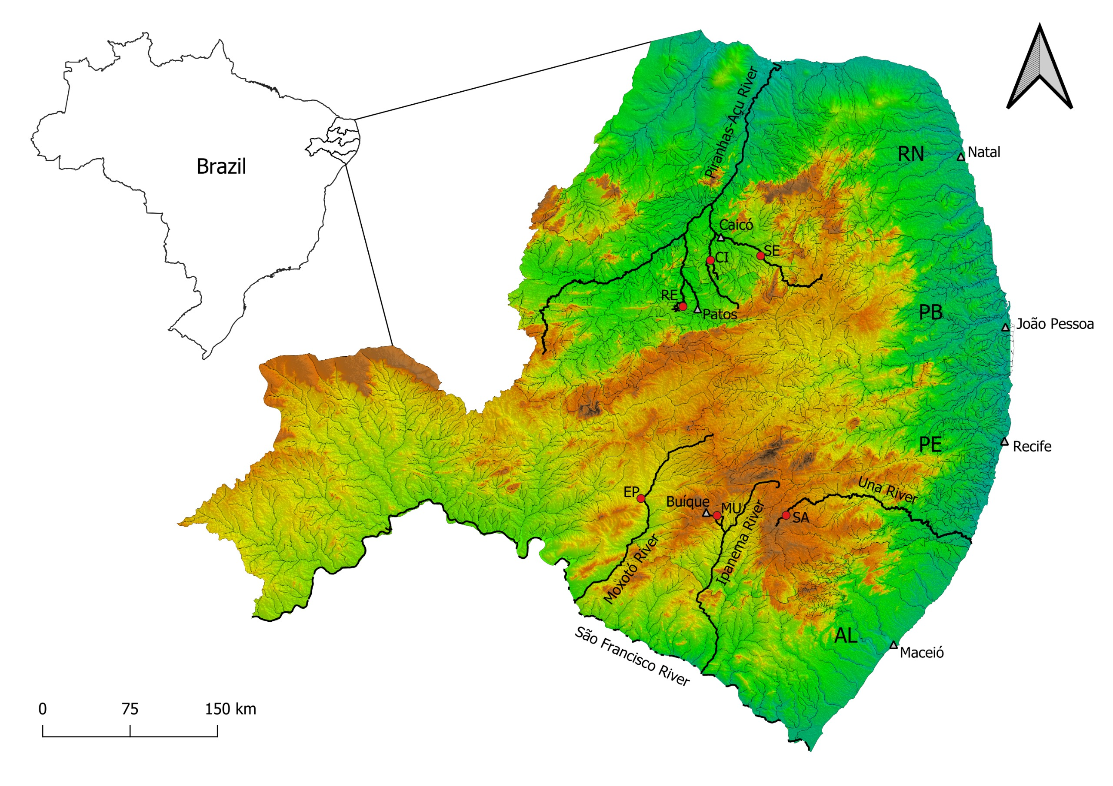
Figure 1: Study sites in semiarid Brazil.
Fig.: Environment data PCA - fviz
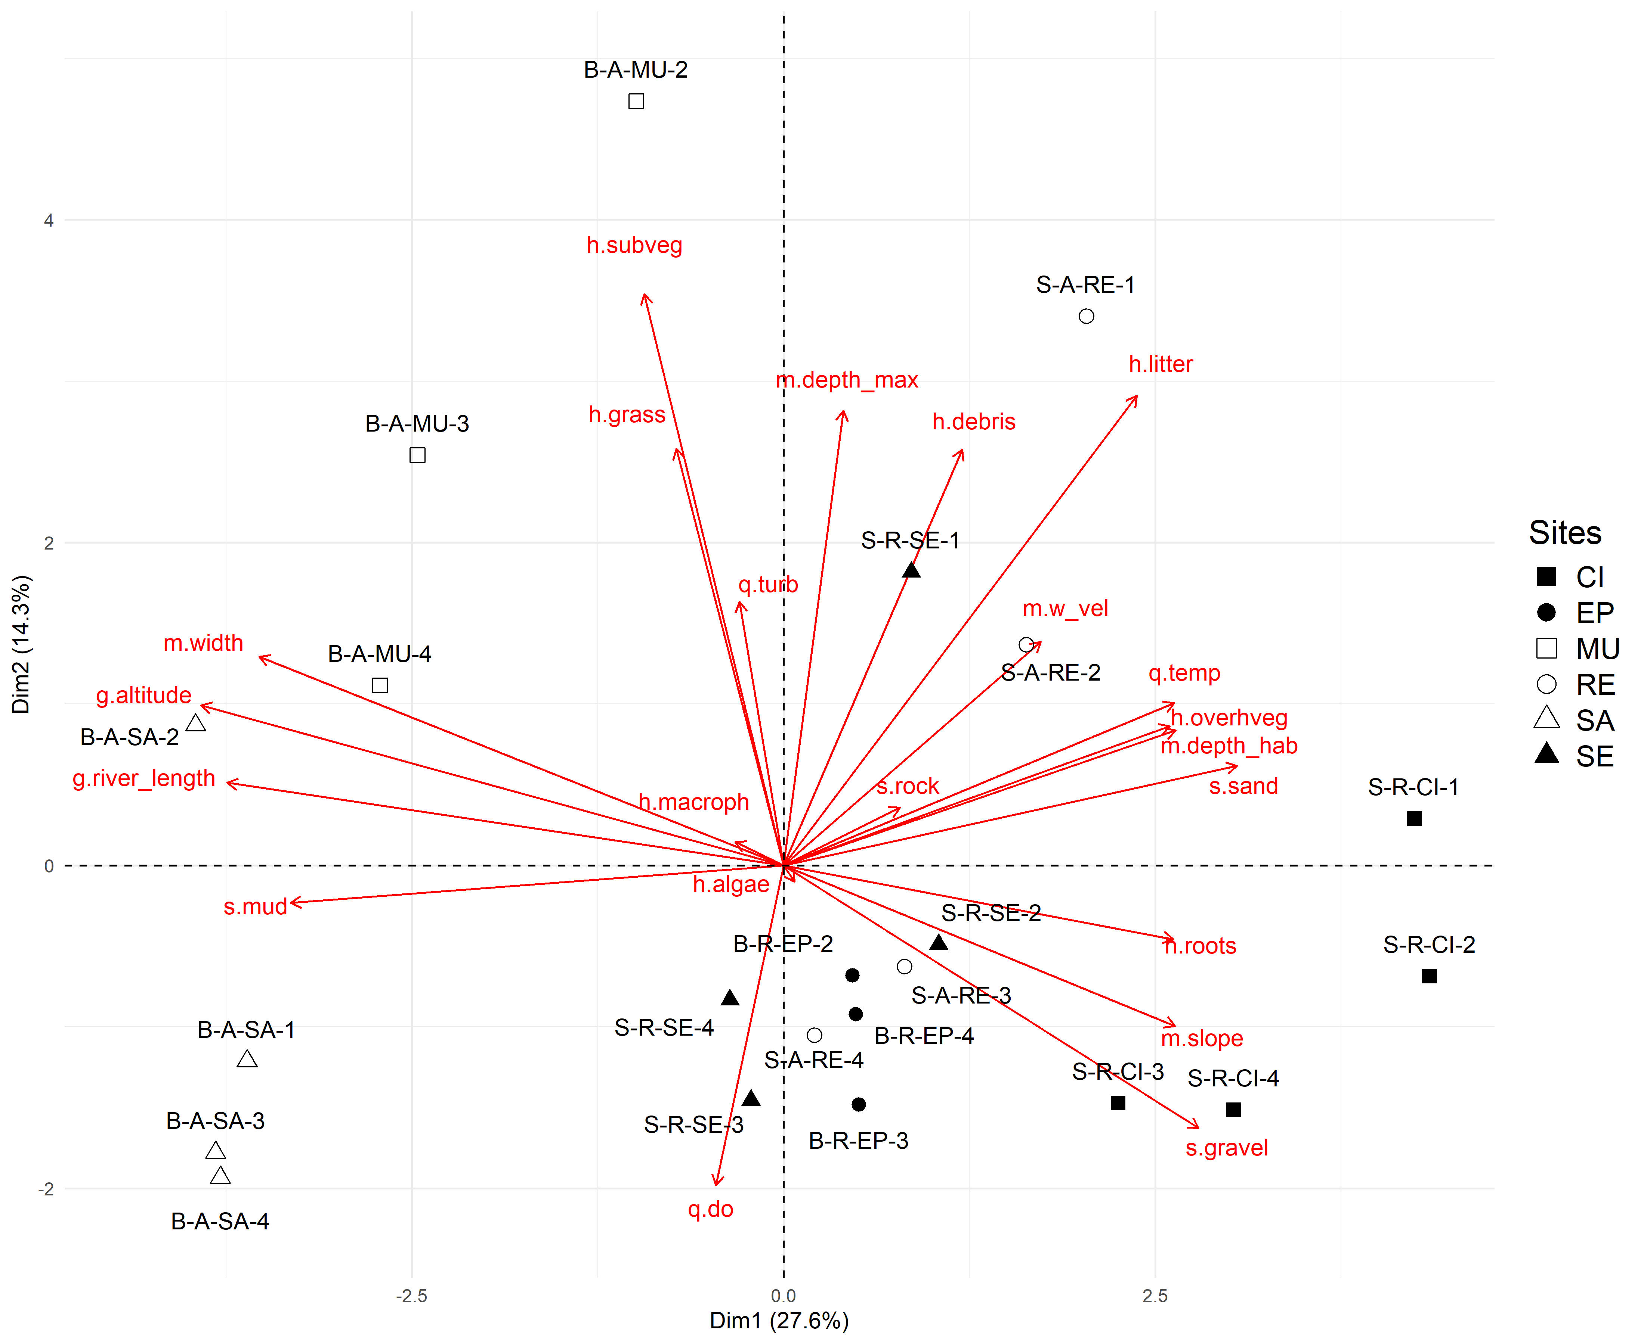
Figure 2: Environment data Principal Component Analysis using the fviz function.
Fig.: Variation in rarefied richness
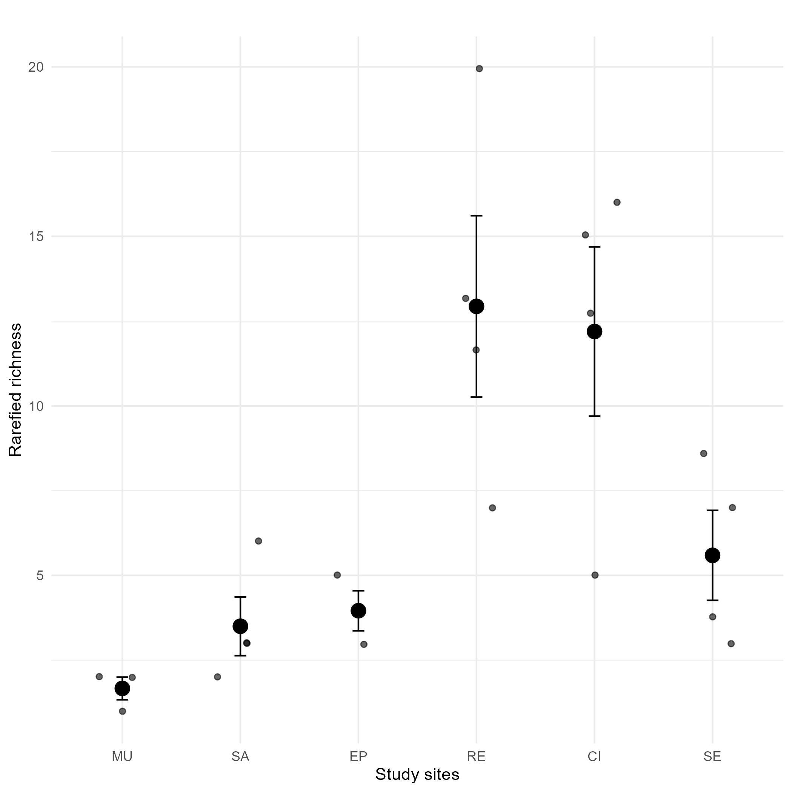
Figure 3: Variation in rarefied richness across study sites.
Fig.: NMDS of community data
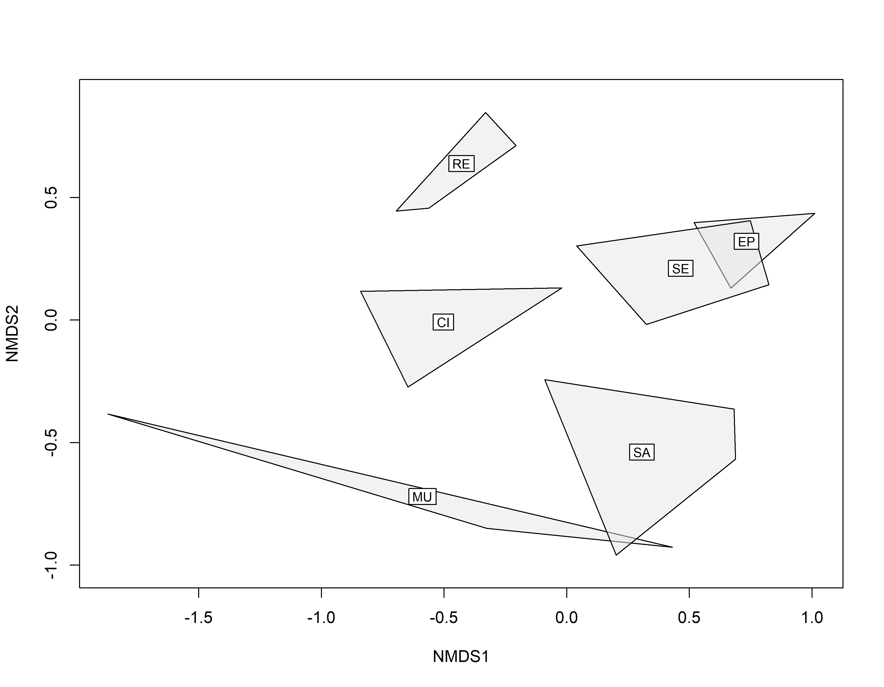
Figure 4: Community data NMDS.
Fig.: Redundace Analisys
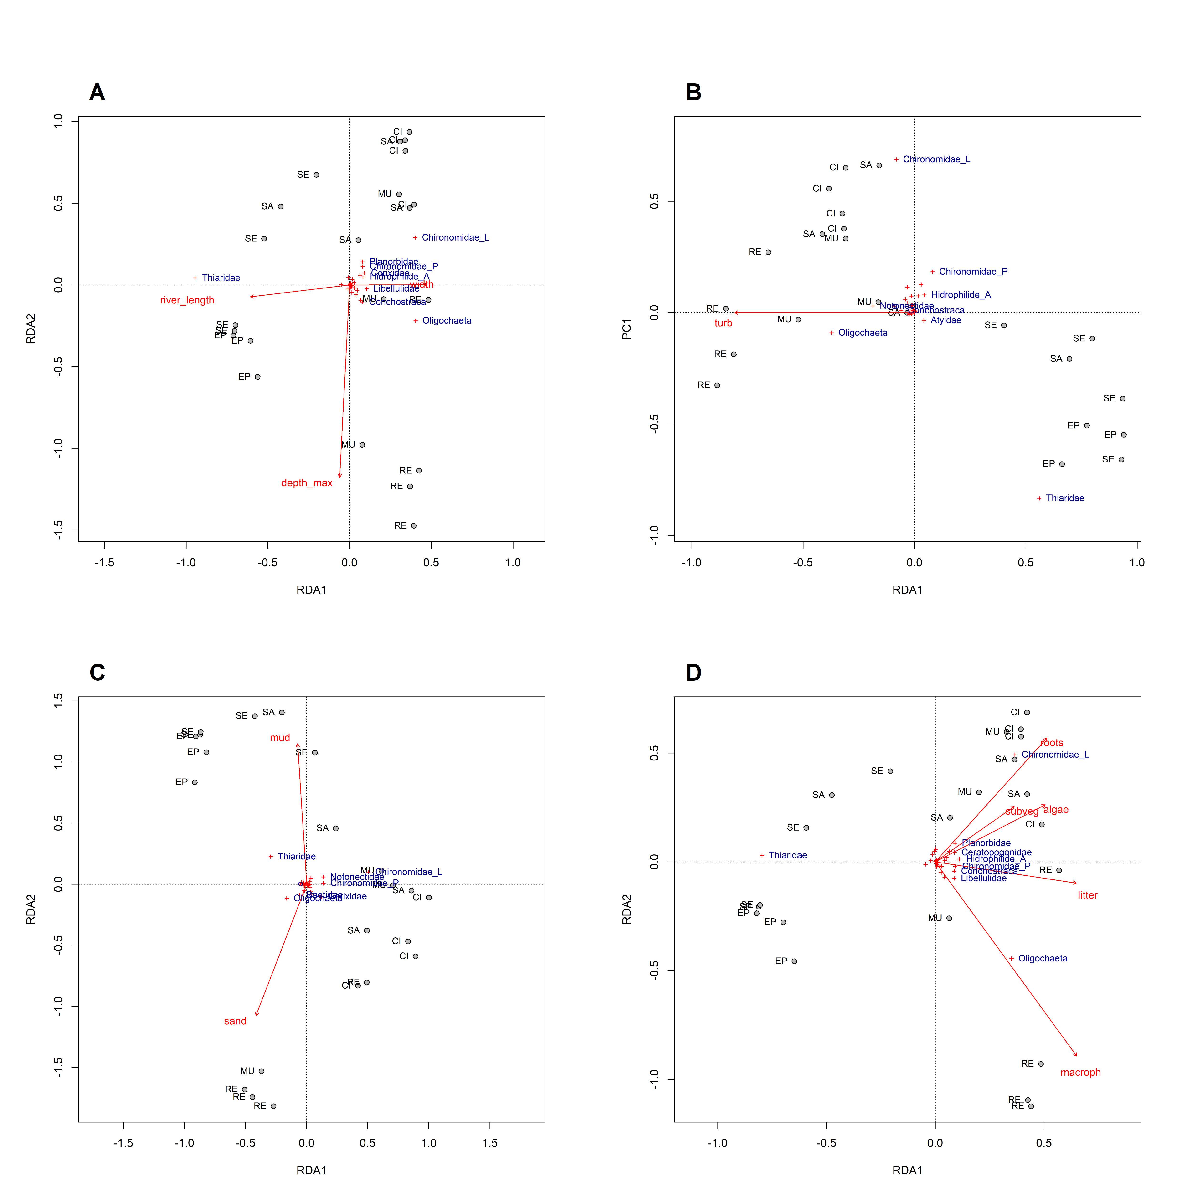
Figure 5: Redundace Analisys.

Tables
Tab.: Environment data GT table
Table 1: Environment data GT table.
Variable | Code | MU | SA | EP | RE | CI | SE
Morfology
River length (m) | g.river.length | 214 (214-214) | 212.7 (212.7-212.7) | 196.8 (196.8-196.8) | 110.2 (110.2-110.2) | 83 (83-83) | 163.2 (163.2-163.2)
Altitude (m.a.s.l.) | g.altitude | 725 (725-725) | 713 (713-713) | 402 (402-402) | 270 (270-270) | 169 (169-169) | 226 (226-226)
Marginal depth (cm) | m.depth.hab | 29.7 (22-41.3) | 6.7 (4.7-8.2) | 50.7 (49.3-52.8) | 36.2 (22.3-54.7) | 33.3 (22.7-45.3) | 53.2 (32.3-81.3)
Maximum depth (m) | m.depth.max | 114.7 (112-117) | 65 (60-69) | 95 (80-110) | 117 (87-154) | 67.8 (60-79) | 98.8 (74-110)
Slope | m.slope | 30 (30-30) | 30 (30-30) | 90 (90-90) | 60 (60-60) | 60 (60-60) | 30 (30-30)
Site width (m) | m.width | 240.4 (234.5-247.6) | 313.7 (289.5-330) | 25.6 (20-29.6) | 90.6 (72.2-102) | 15.4 (10.7-18.5) | 11.8 (5.4-19.6)
Water quality
Watel velocity (m/s) | q.w.vel | 0 (0-0) | 0 (0-0) | 0 (0-0) | 0.025 (0-0.1) | 0.04 (0-0.159) | 0.073 (0-0.167)
Temperature (°C) | q.temp | 27 (26-29) | 26.7 (24-29.2) | 29 (28.9-29) | 31.6 (29-34) | 30.4 (27.6-35.2) | 31.4 (28.3-32.9)
Dissolved oxygen (mg/L) | q.do | 4.9 (1.8-7.3) | 6.1 (1.9-8.8) | 5.2 (5-5.6) | 7.1 (4.8-9.4) | 4.9 (3-6.9) | 6 (5.4-6.5)
Transparency (cm) | q.turb | 65 (43-89) | 42.1 (25.7-55) | 37.4 (30-50) | 67.4 (51.7-90) | 42.3 (26-60) | 30.8 (16-46)
Habitat composition (%)
Macrophyte cover | h.macroph | 0 (0-0) | 12.8 (0-46.7) | 0 (0-0) | 35.7 (5.8-54.8) | 0 (0-0) | 2.1 (0-8.3)
Littoral grass | h.grass | 29.3 (5.6-54) | 5.2 (0-13.3) | 0.7 (0-2) | 2.1 (0-8.1) | 5.8 (0-23.3) | 11.1 (0.1-20)
Submerged vegetation | h.subveg | 15 (0-36.6) | 7.3 (0-26) | 0 (0-0) | 4.2 (0-16.7) | 0.8 (0-3) | 2.5 (0-10)
Overhanging vegetation | h.overhveg | 0 (0-0) | 0.9 (0-3.3) | 0 (0-0) | 10.4 (0-33.3) | 17.1 (0-33.3) | 0 (0-0)
Leaf litter | h.litter | 2.1 (0.4-5) | 0 (0-0) | 0.4 (0.3-0.5) | 1.5 (0.6-3.7) | 1.5 (1-2.3) | 0.4 (0-0.8)
Algae | h.algae | 10.1 (0-30) | 17.3 (0-43.3) | 0.1 (0-0.4) | 17.7 (0-33.3) | 21.4 (0-75) | 5.1 (0-12)
Root masses | h.roots | 0 (0-0) | 0 (0-0) | 0 (0-0) | 0 (0-0) | 2.3 (0-5) | 0 (0-0)
Woody debris | h.debris | 10.7 (10-11.7) | 0.9 (0-3.8) | 1.1 (0.4-2.5) | 7.2 (1.7-13.7) | 4.7 (1-10.3) | 2.6 (0-5)
Substrate composition (%)
Mud | s.mud | 59.1 (20.6-91.8) | 94.4 (87.8-98) | 40.5 (33.7-48.9) | 48.1 (5-81.7) | 17.8 (0.7-48.8) | 66.4 (40-95)
Sand | s.sand | 38.4 (3.2-77) | 3.9 (2-6.7) | 55.6 (47.9-63) | 45.5 (8.3-95) | 60 (22.5-87.7) | 23.7 (1.8-40)
Gravel | s.gravel | 0.8 (0-2.4) | 1.7 (0-5.6) | 3.1 (2-4) | 4.3 (0-13.3) | 19.7 (11.7-28.8) | 6.3 (0.3-20)
Rocks | s.rock | 1.7 (0-5) | 0 (0-0) | 0.8 (0-1.2) | 2.1 (0-8.3) | 2.5 (0-10) | 3.6 (0-8.3)
Tab.: Density of taxa GT table
Table 2: Density (ind/m²) taxa GT table.
Taxa | MU | SA | EP | RE | CI | SE | F.O.(%)
INSECTA
Hemiptera
Belastomatidae | 0 | 0 | 0 | 1(2.1) | 0 | 0 | 4.5
Corixidae | 0 | 0 | 0 | 10.9(21.9) | 447.4(693.4) | 0 | 18.2
Naucoridae | 0 | 0 | 0 | 6.3(11.2) | 0 | 0.5(1.0) | 13.6
Notonectidae | 6.2(10.8) | 0 | 0 | 5.7(11.5) | 22.4(15.5) | 1.6(3.1) | 27.3
Veliidae | 0 | 0 | 0 | 0 | 1.6(3.1) | 0 | 4.5
Coleoptera
Curculionidae | 0 | 0 | 0 | 2.6(5.2) | 0.5(1.0) | 0 | 9.1
Dytiscidae (larvae) | 0 | 0 | 0 | 1(1.2) | 2.1(2.9) | 0 | 18.2
Dytiscidae (adult) | 0.7(1.2) | 0 | 0 | 3.6(7.3) | 4.2(5.1) | 9.4(18.8) | 22.7
Gerridae | 0 | 0 | 0 | 0 | 1(2.1) | 0 | 4.5
Hidrophilidae (larvae) | 0 | 0 | 0 | 5.7(5.7) | 115.1(179.0) | 0.5(1.0) | 27.3
Hidrophilide (adult) | 0 | 0 | 0 | 38(47.2) | 5.2(6.5) | 7.8(15.6) | 31.8
Diptera
Ceratopogonidae | 0 | 0 | 0.7(1.2) | 9.4(12.0) | 25.5(38.7) | 3.6(7.3) | 45.5
Chaoboridae | 0 | 0 | 0 | 0 | 1(2.1) | 0 | 4.5
Chironomidae (larvae) | 4.2(3.6) | 15.1(6.4) | 7.6(6.7) | 509.9(926.2) | 2483.9(2583.7) | 442.2(862.2) | 90.9
Chironomidae (pupae) | 0 | 1(2.1) | 0 | 12.5(25.0) | 57.3(82.5) | 1.6(3.1) | 22.7
Ephemeroptera
Baetidae | 2.1(3.6) | 0.5(1.0) | 0 | 9.4(16.1) | 46.9(86.9) | 0 | 31.8
Caenidae | 0 | 0 | 0 | 14.1(28.1) | 65.1(130.2) | 0.5(1.0) | 13.6
Leptohyphidae | 0 | 0 | 0 | 0 | 18.2(36.5) | 0 | 4.5
Odonata
Coenagrionidae | 0 | 0 | 0 | 8.3(12.6.0) | 0 | 1(2.1) | 18.2
Gomphidae | 0 | 0.5(1.0) | 0.7(1.2) | 1(2.1) | 13(14.5) | 5.7(7.5) | 40.9
Libellulidae | 0 | 0 | 0 | 77.1(39.5) | 47.4(80.2) | 0 | 27.3
Trichoptera
Glossosomatidae | 0 | 0 | 0 | 0 | 3.1(3.6) | 0 | 9.1
Leptoceridae | 0 | 0 | 0 | 0 | 1.6(3.1) | 0 | 4.5
GASTROPODA
Ampularidae | 0 | 0.5(1.0) | 0 | 0 | 1.6(2.0) | 0 | 13.6
Lymnaeidae | 0 | 0 | 0 | 1.6(3.1) | 0 | 0 | 4.5
Planorbidae | 0 | 3.1(4.0) | 0.7(1.2) | 98.4(145.3) | 139.1(218.3) | 132.3(238.6) | 59.1
Physidae | 0 | 0 | 0 | 15.6(18.0) | 0 | 0 | 13.6
Thiaridae | 0 | 16.1(28.3) | 2090.3(1051.4) | 0 | 1(1.2) | 5785.9(5418.1) | 50.0
CRUSTACEA
Atyidae | 0 | 0 | 9(10.7) | 0 | 0 | 24(28.5) | 18.2
Conchostraca | 0 | 0 | 0 | 93.8(146.0) | 0 | 0 | 13.6
Ostracoda | 0 | 0 | 0 | 67.7(131.3) | 0 | 0 | 9.1
ANNELIDA
Hirudinea | 0 | 0 | 0 | 4.2(5.1) | 0 | 0 | 9.1
Oligochaeta | 0 | 1.6(2.0) | 95.8(143.2) | 2016.1(869.3) | 3.1(2.7) | 0 | 50.0
BIVALVIA
Sphaeridae | 0 | 0 | 0 | 0 | 0.5(1.0) | 0 | 4.5
TROMBIDIFORMES
Hydrachnidia | 0 | 0 | 0 | 0 | 23.4(46.9) | 0 | 4.5

Apendices

Non-used figures and tables
Fig.: Environment variables pairs
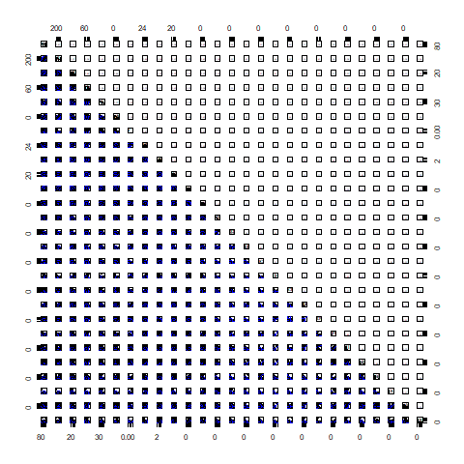
Figure 6: Environment variables correlations pairs.
Fig.: Habitat variables correlations plot
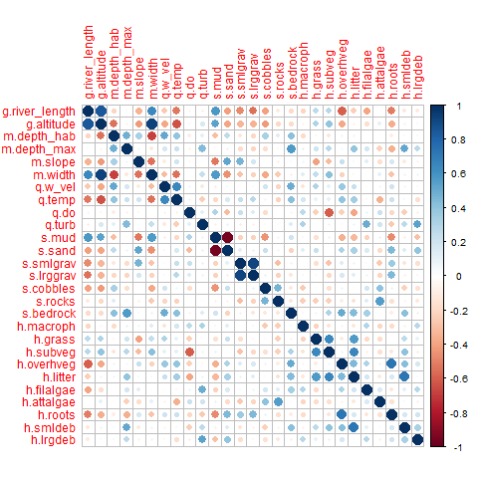
Figure 7: Habitat variables correlations correlogram.
Fig.: Environment data PCA - R Base
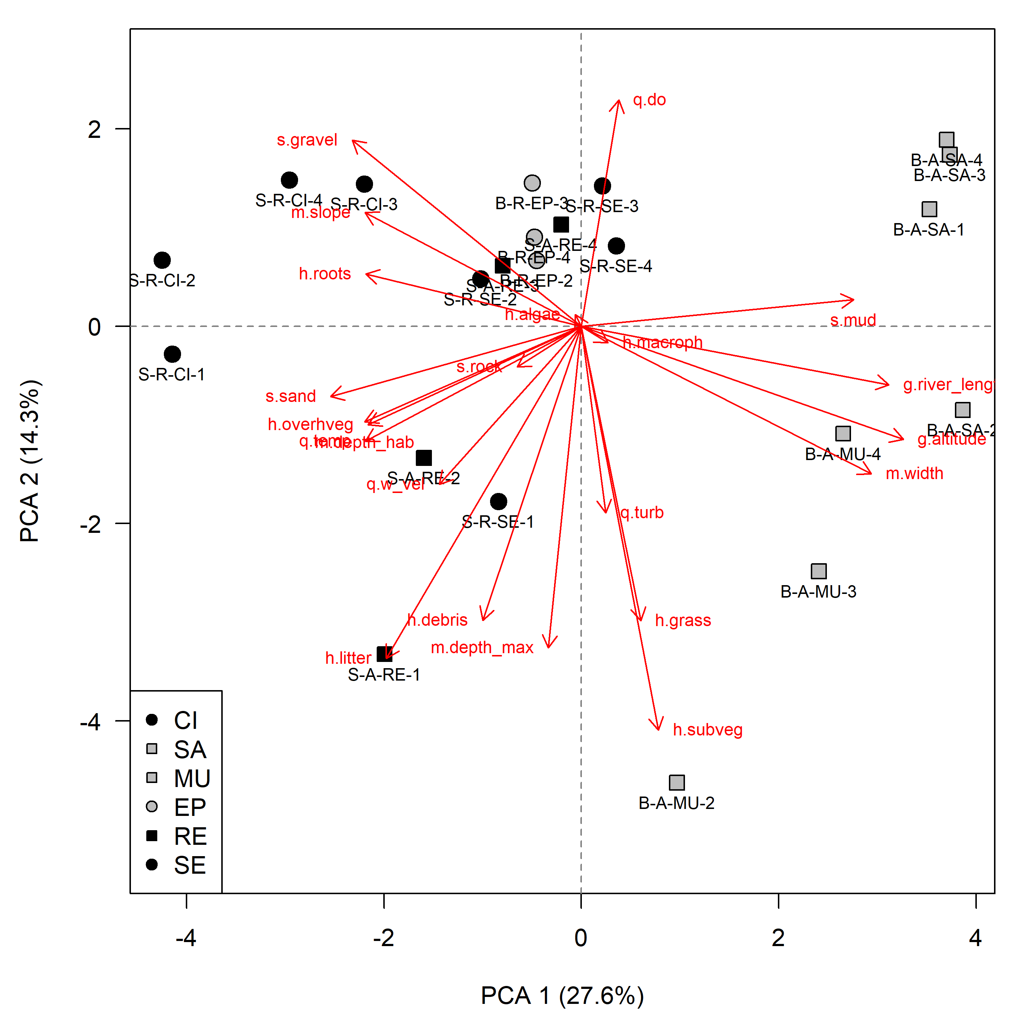
Figure 8: Environment data Principal Component Analysis using the prcomp and plot functions.
Fig.: Multilevel Pattern Analysis of indicator species
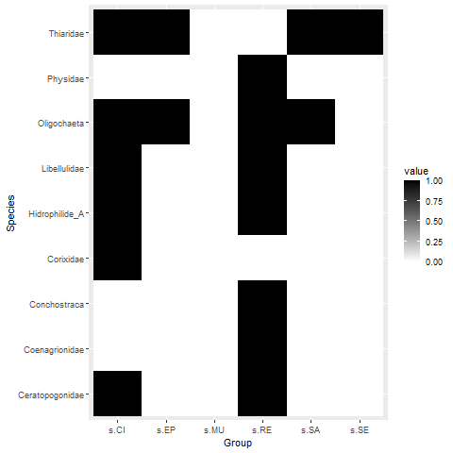
Figure 9: Multilevel Pattern Analysis of indicator species.
Tab.: Environment data GT table
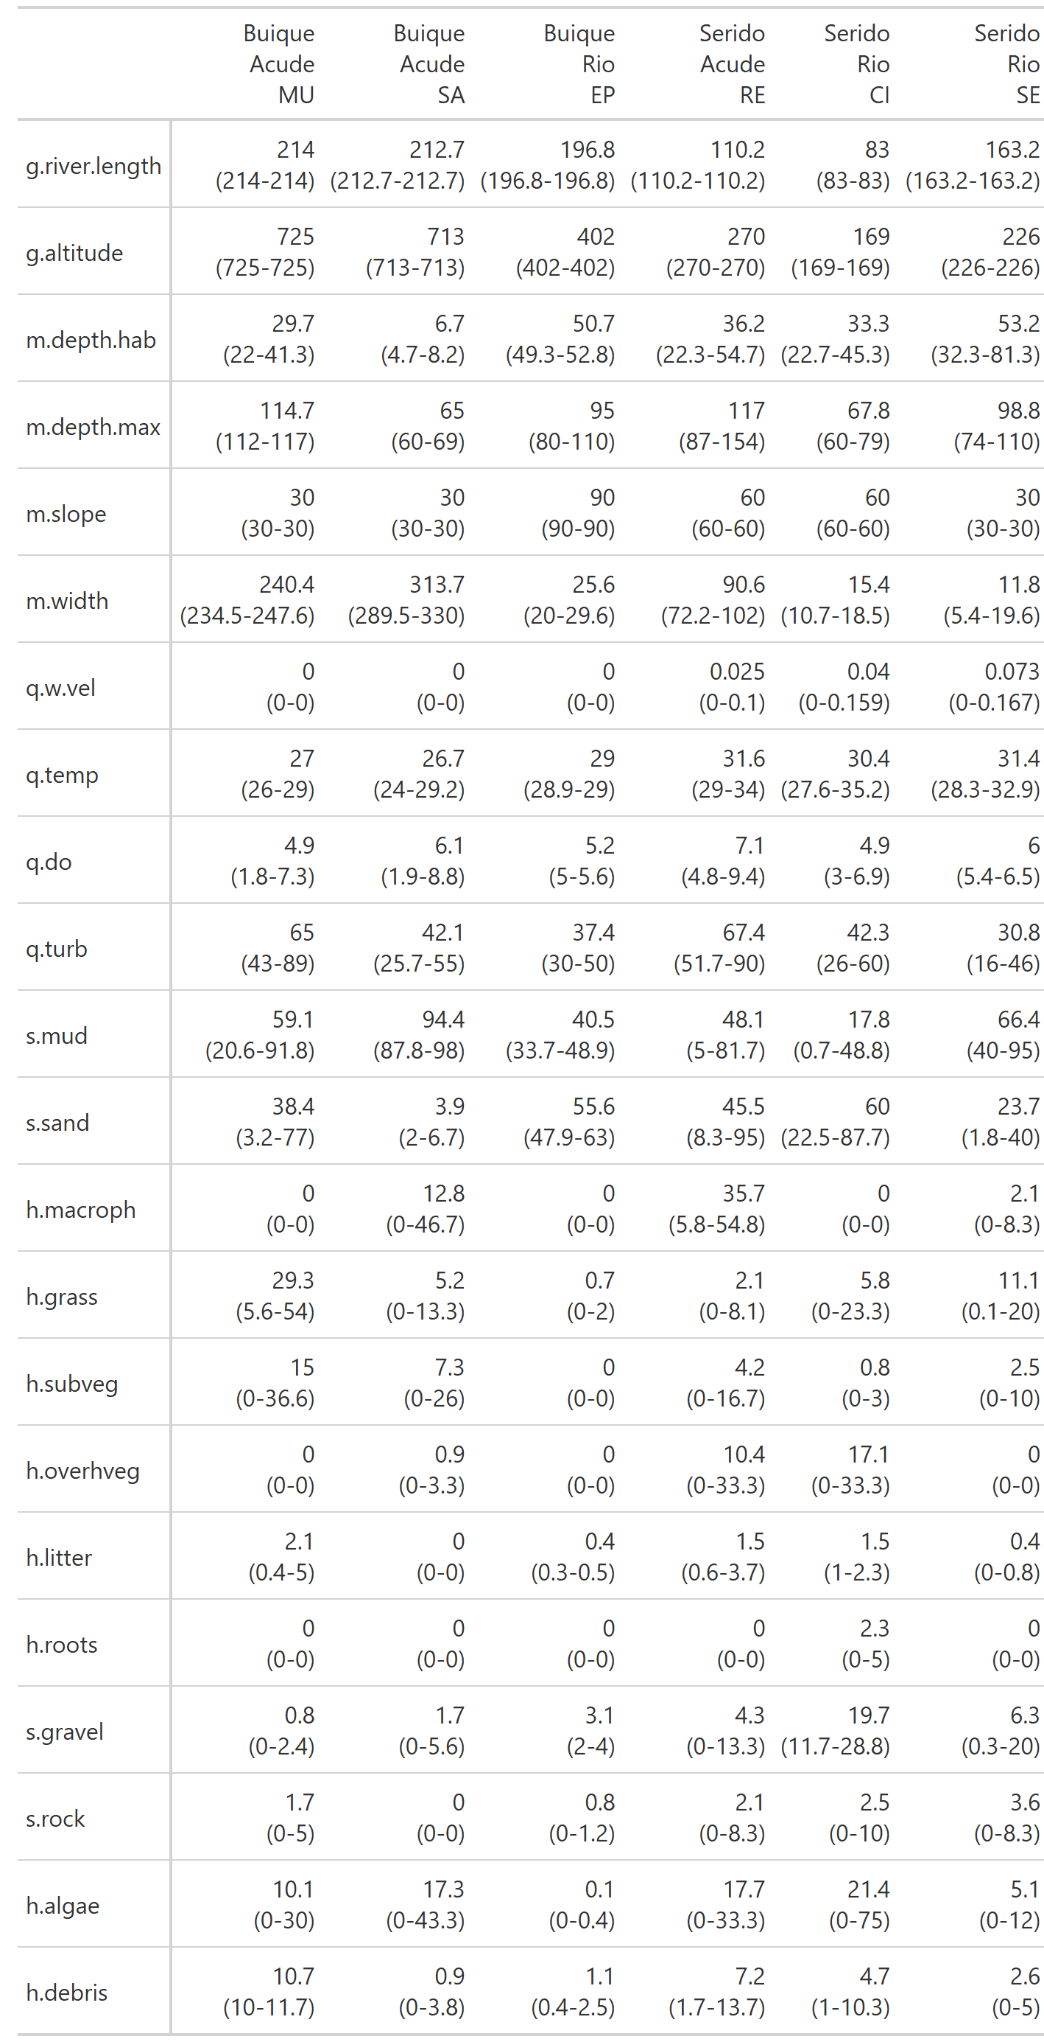
Figure 10: Environment data GT table
Tab.: Density data table
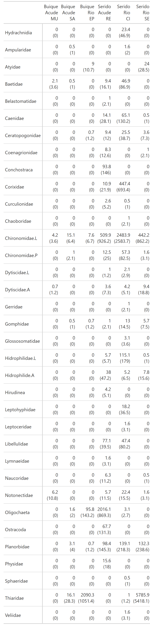
Figure 11: Density of species data table.
Tab.: Diversity descriptors data table
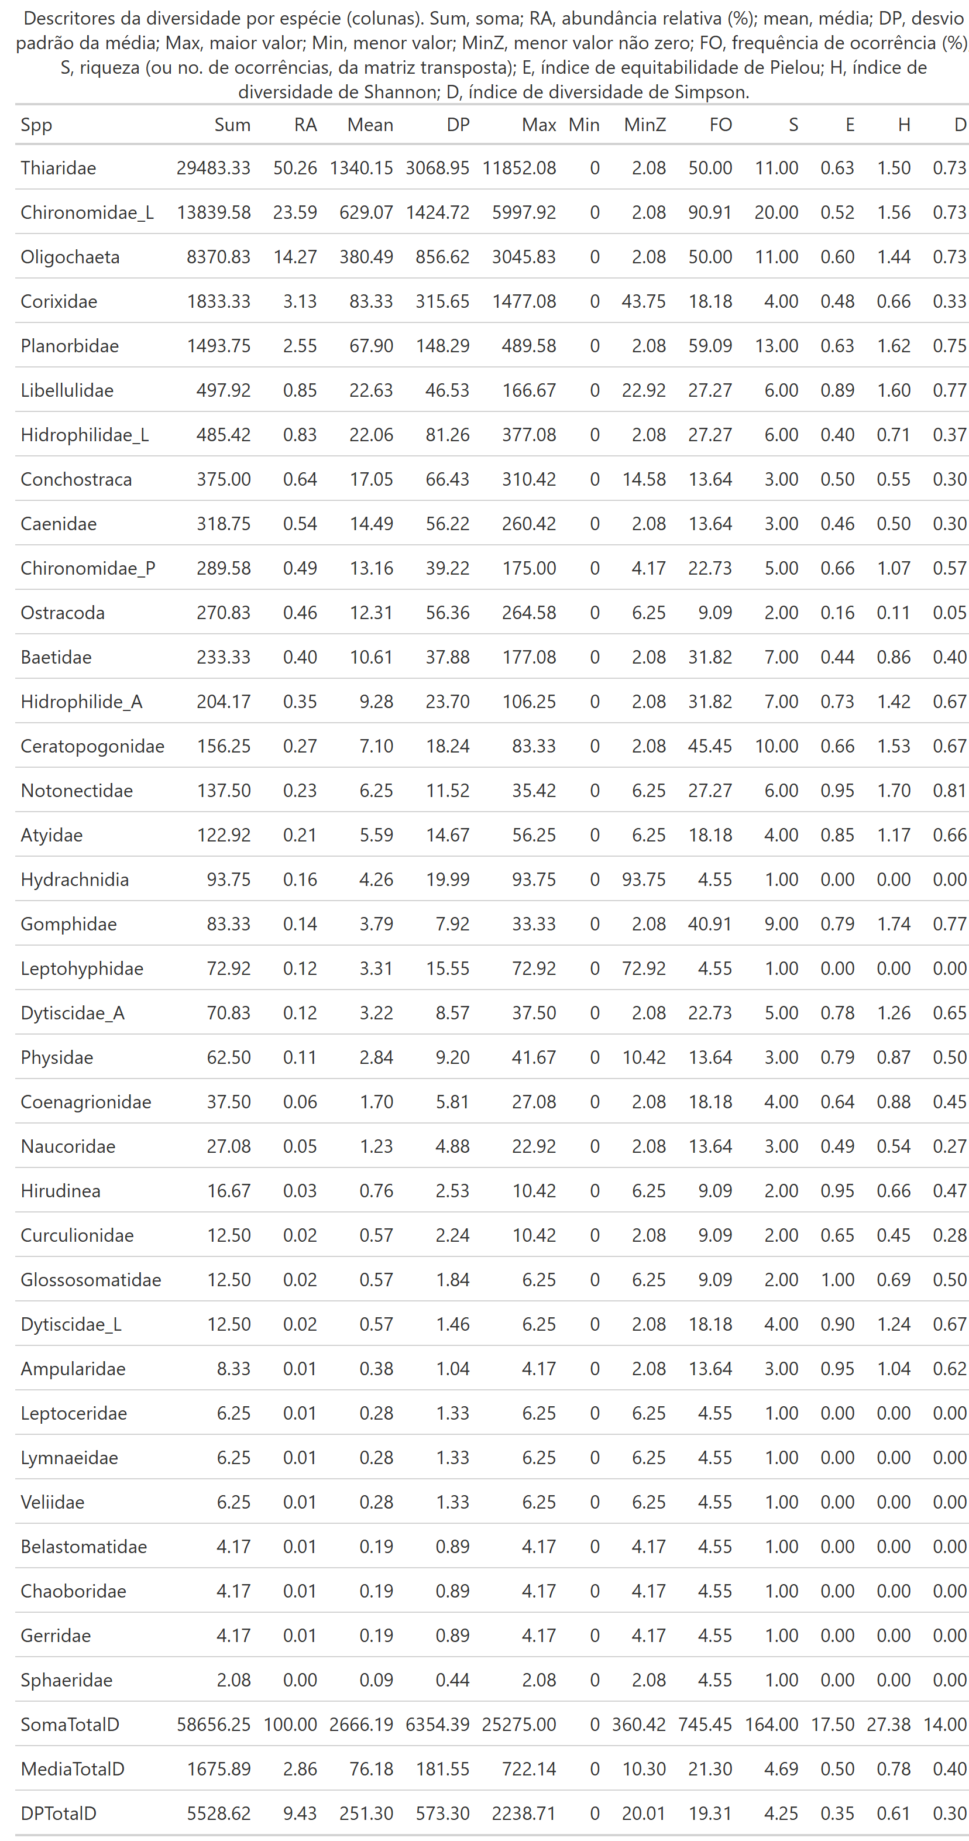
Figure 12: Diversity descriptors of the community structure data table.
 Non-used code

